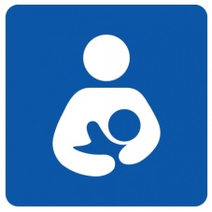

**Breastfeeding Support Resources**

Chesapeake Regional Healthcare

800 Battlefield Blvd., North  
Chesapeake, VA 23320

Classes are held the first Tuesday of each month from 5:30-8:30 PM – Cost $15

Call: 757-312-6508 for information

Sentara – Obici Hospital

Classrooms A-D

2800 Godwin Blvd.

Suffolk, VA, 23434

Classes are held virtually monthly on Saturday from 8:30-10:30 AM – Cost $10

Register at Sentara.com or call 1-800-SENTARA (1-800-736-8272).

Chesapeake Health Department WIC

If you would like to learn more about how the Chesapeake Health Department WIC Program supports breastfeeding or have breastfeeding questions, please call our Breastfeeding Line at 757-831-1748, available 24 hrs/day

Virginia Breastfeeding Coalition

vabreastfeedingcoalition.org

Virginia La Leche League

lllvawv.org

Department of Health and Human Services

womenshealth.gov/breastfeeding

(800) 994-9662